**ORIENTATION KIT**

**for**

**Integrated Child Protection Scheme (ICPS) and the Allied Workforce**

Role of ICPS & allied workforce during COVID-19

As you know an emerging respiratory disease called COVID-19 is spreading across the world. COVID-19 is caused by the virus SARS-CoV-2. On the 11th of March 2020, the World Health Organization (WHO) has declared COVID-19 a ‘Pandemic’. The Government of India has undertaken a pan-India approach to address COVID in country, involving various line Ministries and all States/UT.

India has also reported more than 2500 cases from states and the government is trying its best to contain the spread of the disease. In the view of the current situation, the government of India has taken the decision to apply ‘lockdown’ strategy across all states to halt the spread of the coronavirus outbreak.

Government of India is taking all necessary steps to ensure that we are prepared well to face the challenge and threat posed by the growing pandemic of COVID 19 – the Corona Virus. With active support of the people of India, we have been able to contain the spread of the Virus in our country. The most important factor in preventing the spread of the Virus locally is to empower the citizens with the right information and taking precautions as per the advisories being issued by Ministry of Health & Family Welfare.

The **Integrated Child Protection Scheme** (ICPS) is a centrally sponsored scheme aimed at building a protective environment for children in difficult circumstances, as well as other vulnerable children, through Government-Civil Society Partnership. ICPS brings together multiple existing child protection schemes of the Ministry under one comprehensive umbrella and integrates additional interventions for protecting children and preventing harm. ICPS, therefore, would institutionalize essential services and strengthen structures, enhance capacities at all levels, create database and knowledge base for child protection services, strengthen child protection at family and community level, ensure appropriate inter-sectoral response at all levels.

Infectious diseases like COVID-19 can disrupt the environments in which children grow and develop. Disruptions to families, friendships, daily routines and the wider community can have negative consequences for children’s well-being, development and protection. In addition, measures used to prevent and control the spread of COVID-19 can expose children to protection risks. Home-based, facility-based and zonal-based quarantine and isolation measures can all negatively impact children and their families. In today’s digital world, children also access different kinds of information and news through social media and digital platforms, some of them may not be factually true, causing further stress and anxiety. It is enhanced when children are not able to go out, play, attend school or interact freely. For those children and families who are subjected to mandatory quarantine or isolation there may be an increased risk of violence and abuse. When stress levels go up for adults and children, there is a greater risk of Gender-Based-Violence and violence against children. This module has been designed to support child protection practitioners (*District Child protection units, Child welfare committees, Child Care Institutions etc*.) including the allied forces(*Police, para-legal support workers, para-medical, community level health and social welfare workers etc*.) to better respond to the child protection risks during a COVID-19 pandemic.

**Your Role as ICPS and allied workforce is two-fold -**

* Spread key messages in the community about measures to prevent the infection.
* Provide information and support for Mental Health and Psychosocial Support to people infected or affected by COVID-19.
* Identify, prevent and respond to issues of violence and abuse, which may be exacerbated in context of anxiety and stress produced by COVID-19 and the associated lockdown.
* Support most vulnerable populations (migrant and daily wage workers/children especially street connected children/senior citizens) to access services, social protection benefits and messages about measures to prevent the infection

**MODULE SESSIONS**

**What is COVID-19?**

COVID-19 is a disease caused by the “novel corona virus”.

**What are the Common symptoms are?**

* Fever
* Dry cough
* Breathing difficulty
* Some patients also have aches and pains, nasal congestion, runny nose, sore throat or diarrhoea

About 80% of confirmed cases recover from the disease without any serious complications. However, one out of every six people who gets COVID-19 can become seriously ill and develop difficulty in breathing. In more severe cases, infection can cause severe pneumonia and other complications which can be treated only at higher level health facilities (e.g. District Hospitals and above). It’s only in a few cases it may even cause death.

**How does COVID-19 spread?**

* COVID-19 spreads mainly by droplets produced as a result of coughing or sneezing of a COVID-19 infected person. This can happen in two ways:
* Direct close contact: one can get the infection by being in close contact with COVID-19 patients (within one Meter of the infected person), especially if they do not cover their face when coughing or sneezing. Indirect contact: the droplets survive on surfaces and clothes for many days. Therefore, touching any such infected surface or cloth and then touching one’s mouth, nose or eyes can transmit the disease.
* The incubation period of COVID 19 (time between getting the infection and showing symptoms) is 1 to 14 days
* Some people with the infection, but without any serious symptoms can also spread the disease.

**Which group of people are at higher risk of getting infected?**

* People who have travelled to other countries in last 14 days and their family members.
* People coming from other states or districts or areas where there are confirmed COVID-19 cases or
* Family members and contacts of patients confirmed to have COVID-19.
* People older than 60 years of age and people with medical problems like high blood pressure, heart problems, respiratory disease/asthma, cancer or diabetes are at higher risk for developing serious complications

**How are children affected by COVID 19?**

* Children may have increased stress and anxiety due to fear of being sick or losing their loved ones.

borne out of lack of knowledge, rumors and misinformation, lack of regular school activity and outside contact.

* Violence, including sexual and gender-based violence may be exacerbated in contexts of anxiety and stress produced by lockdown and fear of the disease
* Children of migrant workers, those living on streets or crowded slums are at greater risk as they lack basic services for water, sanitation, health, information and messages from authentic sources. They also face greater risk of violence, abuse, exploitation, trafficking.

**Key messages to spread for prevention of COVID-19 -**

1. **How to avoid getting COVID-19 or spreading it?**

**DEW: Distancing, Etiquettes and Washing hands**

1. 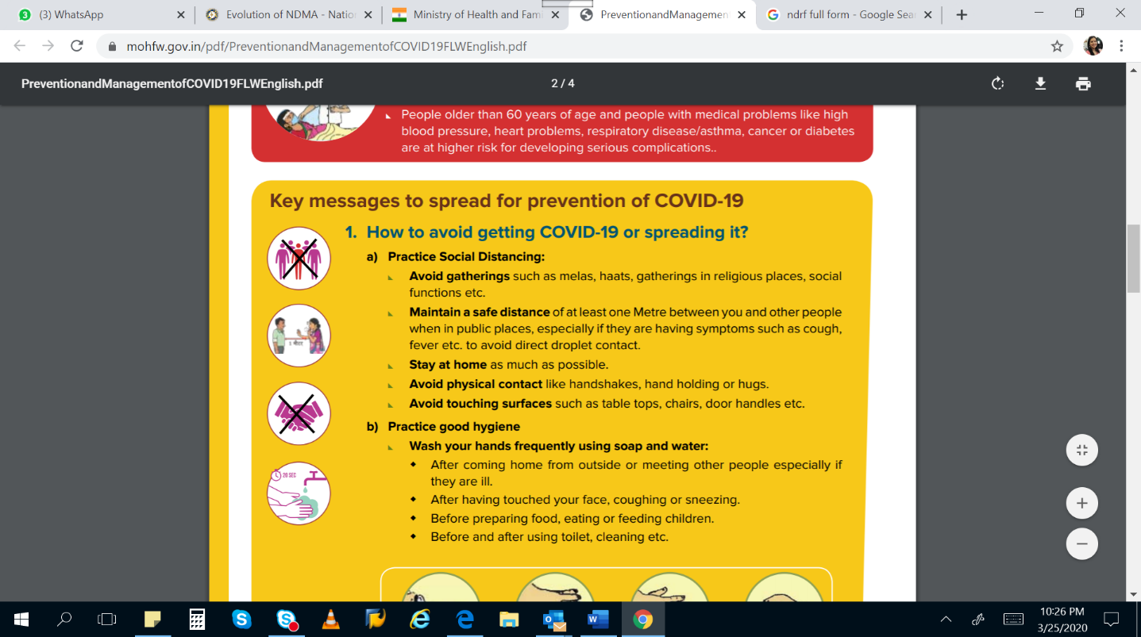**Practice Social Distancing:**

* Avoid gatherings such as melas, haats, gatherings in religious places, social functions etc.
* Maintain a safe distance of at least one Meter between you and other people when in public places, especially if they are having symptoms such as cough, fever etc. to avoid direct droplet contact.
* Stay at home as much as possible.
* Avoid physical contact like handshakes, hand holding or hugs.
* Avoid touching surfaces such as tabletops, chairs, door handles etc.

1. **Practice good hygiene:**

* 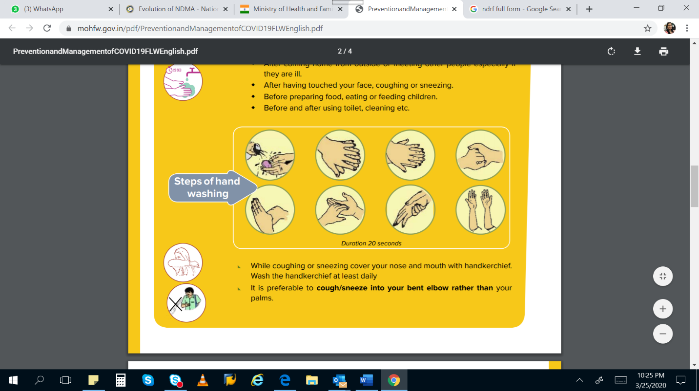Wash your hands frequently using soap and water:
* After coming home from outside or meeting other people especially if they are ill.
* After having touched your face, coughing or sneezing.
* Before preparing food, eating or feeding children.
* Before and after using toilet, cleaning etc.

1. **Respiratory etiquettes:**

* While coughing or sneezing cover your nose and mouth with handkerchief. Wash the handkerchief at least daily
* It is preferable to cough/sneeze into your bent elbow rather than your palms.
* Do not spit or shout in public places to avoid the spread of droplets.
* Do not touch your eyes, nose and mouth with unclean hands. Ensure that the surfaces and objects are regularly cleaned.

1. **What to do if you are having symptoms or have travelled to other countries or states in past two weeks?**

* Symptoms of COVID 19 and seasonal respiratory illness (common cold/flu) are similar. All people with these symptoms may not have COVID 19.
* Following persons should be quarantined for 14 days at home as a precaution:
  + People who have travelled to COVID 19 affected countries/areas in past 14 days
  + Those who have come in close contact with a suspected/confirmed COVID 19 patient
  + Those who develop symptoms
* These persons should inform you. If symptoms become severe then the person should visit a health facility after speaking with you.

**What is your role as ICPS and allied workforce?**

* Share names of infected or affected persons with your nearest Medical Officer at PHC but not with others
* Teach infected and affected persons about Home Quarantine for next 14 days
* Tell them to monitor themselves for symptoms of COVID-19
* Tell them to inform you if symptoms develop and call the COVID 19 Helpline 1075 or 011-23978046
* Be kind and speak calmly and gently to persons, especially those who are sick, are caregivers of the sick or otherwise vulnerable.
* To be compassionate and considerate of people who are infected and affected by COVID-19
* To set an example by not ostracizing or discriminating against persons who are quarantined. Where others do so, to step in and advise them to be respectful and compassionate. educate and counsel people to avoid stigmatizing, ostracizing and discriminate against families or people infected or affected by COVID-19
* Be mindful of the needs of children, especially children of migrant workers, those living on streets or crowded slums who do not have access to services, protection of family care and right kind of information. Call CHILDLINE 1098 and the district Child Welfare Committee to support these children.
* Refer cases of violence to the police. Refer cases of suspected child abuse to Child Line (1098). Refer cases of suspected domestic violence to the Women’s Hot Line (1091).
* Be alert that violence, abuse and deprivation do increase in emergency/disaster situations. Be vigilant, take action and report. Be aware that domestic violence and other forms of violence against women and girls goes up during any time of stress. Report any suspected cases of violence against women to 1091. If there are cases of suspected trafficking or child marriage, call 1098 or report to the police immediately.
* To provide referral and rescue services to people infected or affected by COVID-19
* Provide volunteer support to people for basic necessity services like food, medicine, transfer to hospital etc.

**HOME QUARANTINE:**

* The list of persons with home quarantine is available with the District Integrated Surveillance Programme Medical Officer. These persons have either traveled outside the country or have come in contact with a laboratory confirmed case of COVID-19. These persons are not supposed to come outside their home for at least 14 days. Support them in following these rules peacefully and with calm, compassionate advice on the rules and protocol.

**What to instruct/inform to person being Home Quarantined?**

* Stay in a separate well-ventilated room at home, if possible, with an attached/separate toilet. Try to maintain a distance of at least 1 meter from others
* Restrict his/her movement so that she or he remains within the house.
* Wear a mask at all times. If masks are not available, take a clean cotton cloth, fold it into a double layer and tie it on your face to cover your nose and mouth
* Use separate dishes, towels, bedding etc. which should be cleaned separately
* Make sure that only one assigned family member is the caretaker
* Needs to stay away from all other persons in the household. This is especially important with regard to persons over the age of 60, pregnant women, children and persons with illnesses.
* If children without parental care are identified (children whose parents or main care takers are quarantined or even have deceased), please contact the Child Protection and Child Welfare Services from the Ministry/Department of Women and Child development (MWCD, DWDC).
* If children without parental care are identified (children whose parents or main care takers are quarantined or even have deceased), please contact CHILDLINE 1098 and the district Child Welfare Committee /Department of Women and Child development (MWCD, DWDC).

**What to instruct/inform parents and caregivers to help children cope with COVID 19?**

* Be patient with children and understand their emotions. These are valid emotions and as parents and adults, we need to understand them.
* Talk to your children about what is happening in a way that they can understand. Keep it simple and appropriate for each child’s age.
* Give your children opportunities to talk about what they are feeling. Encourage them to share concerns and ask questions.
* Assure your children that you are prepared to keep them safe. Provide them with correct information through valid sources.
* Avoid watching, reading, listening or discussing too much news about the COVID-19 and persuade children to divert their attention to other topics as well.
* Keep a calm and conducive environment within the family as far as possible
* Issues of violence, abuse and deprivation may be exacerbated in the context of stress and economic deprivation. Be aware of these risks and help in protecting children

**Instructions for the caretakers -**

**What should a Home Quarantined person do?**

* Keep a distance of one meter from the quarantined person when entering their room
* Wear a mask or cover your face with double layered cotton cloth at all times while in the room
* Wash your hands after coming out of the room
* Ensure that the surfaces such as floor, tabletops, chairs, door handles etc. should be cleaned at least once a day with soap and water
* Ensure that the person does not come into contact with anyone else. This is especially important for persons over the age of 60, persons with illnesses, young children and pregnant women.

**How to use masks (or cloth covering the nose and mouth)**

* Wash your hands before putting on the mask
* Make sure that it covers both mouth and nose and is not loose.
* Do not touch the mask from the front, touch only from the sides.
* Make sure to wash your hands after changing the mask
* Change the mask every 6-8 hours. If it becomes moist before that, discard the mask and wear a fresh one.
* If using disposable masks, have a dustbin with cover and a plastic bag lining to throw the masks in.
* If using cloth masks, wash them at least daily

**Designated Hospitals: (See government lists)**

* There are hospitals designated by the Government for treatment of COVID-19 patients.

Role:

* Crowd management – ensure that everyone maintains Maintain a distance of one meter from each other
* Advising all to wear masks when inside the hospital
* Advising about handwashing, social distancing and cough and sneeze etiquettes.

**AMBULANCE:**

* Transport of a suspected COVID-19 case from home to hospital

Role:

* Crowd management -
* ensure that everyone maintains a distance of one meter from each other
* Safe passage to the ambulance
* Advising against stigmatization
* Advising about handwashing, social distancing and cough and sneeze etiquettes.

**Dead body Management and Funeral: (See government advisory)**

* Death of a confirmed or suspected COVID-19 case

Role:

* Empathy with the family and friends through a distance of atleast one meter
* Staying in touch with the key family members and friends for counselling
* Crowd management –
* ensure that everyone maintains a distance of one meter from each other
* Safe passage to the destination
* Liase with crematorium for speedy cremation,
* Liase with health officials for arrival to the crematorium
* Advising against stigmatization

**Routine Health Services:**

* Routine and elective health services are suspended, only critical and emergency health services are permitted.

Role:

* Facilitate movement of ambulance for critical services like delivery by pregnant women, sick children transport, accident victim etc.
* Ensure that emergency medical and surgical services are functional including labour rooms, SNCU, ICU, blood bank, burn ward, organ and tissue transplant, etc.
* Ensure that there is no restriction of movement of health staff including doctors, nurses, wards boys, aayaas, ANM, ASHA, ambulance drivers etc.

**How to take care of yourself and carry on with your duties as a ICPS and allied workforce?**

Take all preventive measures that you are talking about in the community such as keeping safe distance, washing hands frequently or use 70% alcohol-based hand rub including before and after home/community visits. Carry your own soap or 70% alcohol-based hand rub if necessary

* If you are visiting or accompanying a suspected case to any health facility, make sure to cover both your mouth and nose with N95 mask. Maintain 1-meter distance.
* Maintaining safe distances for those living in crowded areas or the homeless is going to be difficult. Even then you should inform them about preventive measures and provide what support is possible.
* Self-monitor for signs of illness and report to the Medical Officer, immediately if any symptoms develop.
* Remember persons over the age of 60 are at higher risk, so take special care to visit their homes and ensure that they have the provisions and support they need so that they don’t have to leave the house more than is necessary.
* Continue to pay special attention to the marginalized and vulnerable populations, as is your routine practice. Ensure that they follow the DEW protocol especially in night shelters, slums etc.
* Also, as a disaster response worker, try to reassure people that while those with symptoms and high risk need close attention, for others, prevention measures will decrease the risk of getting the disease.

**How to help people infected and affected by COVID-19 cope and manage stress?**

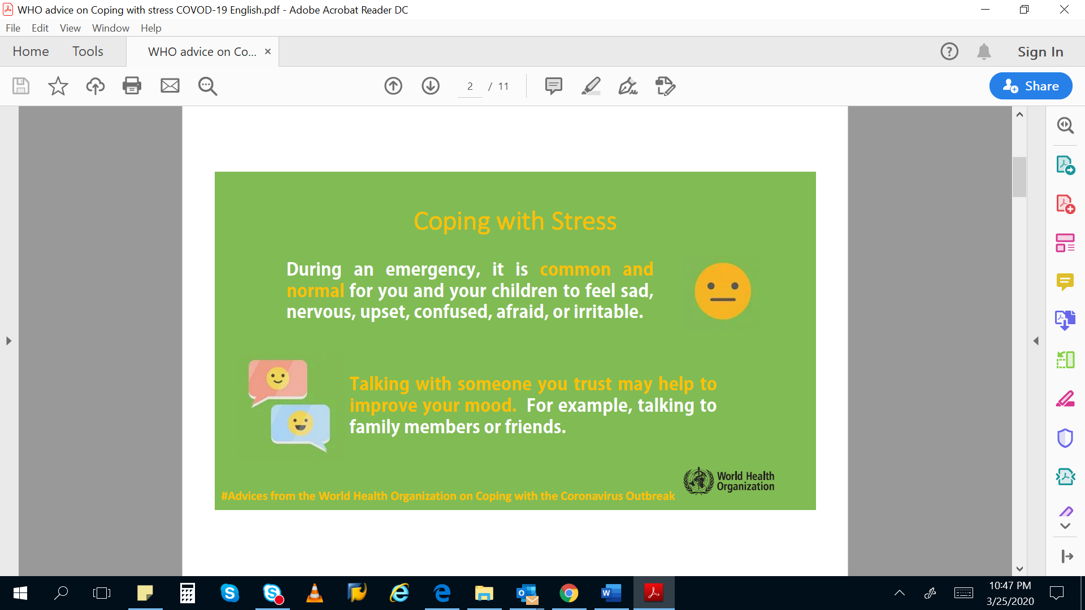

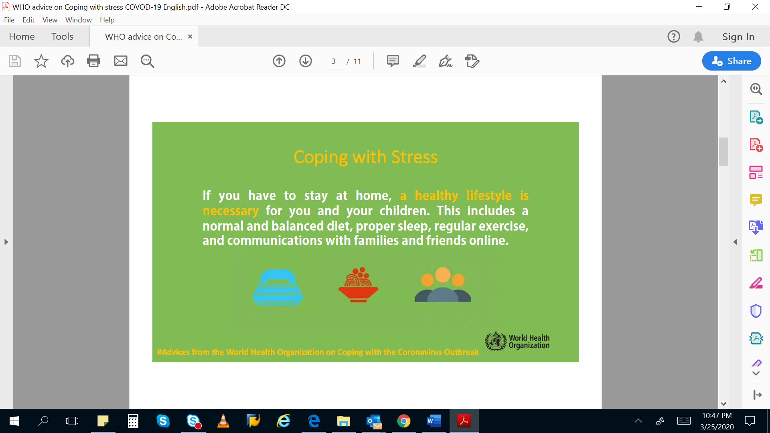

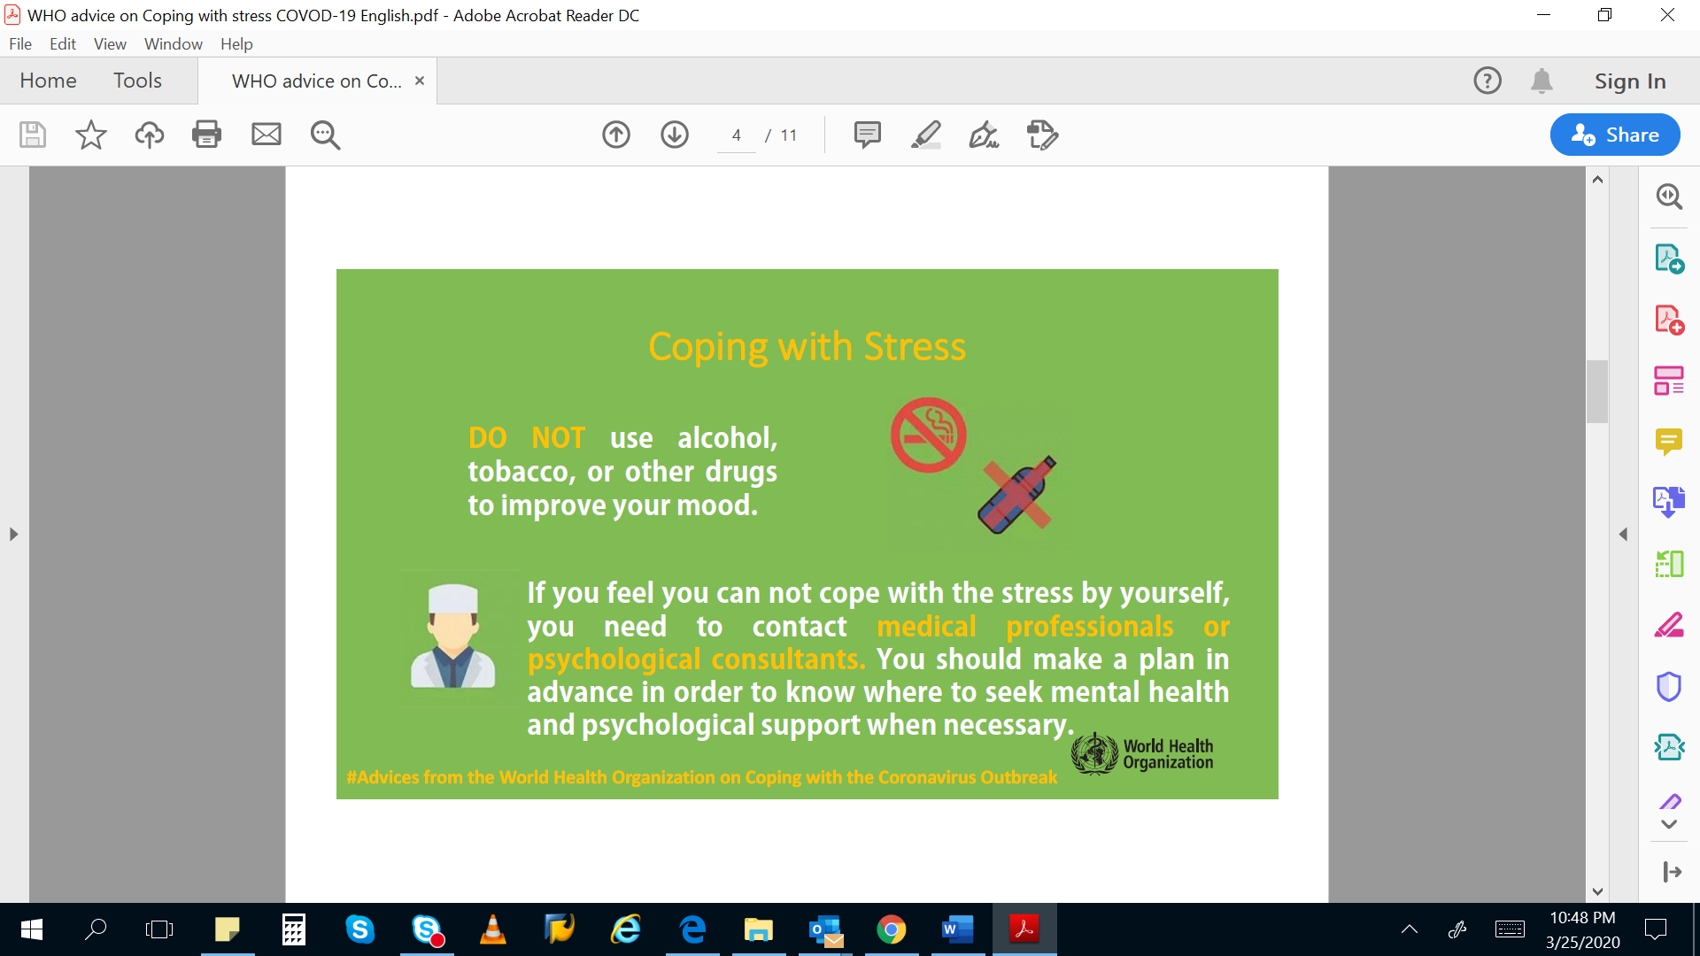

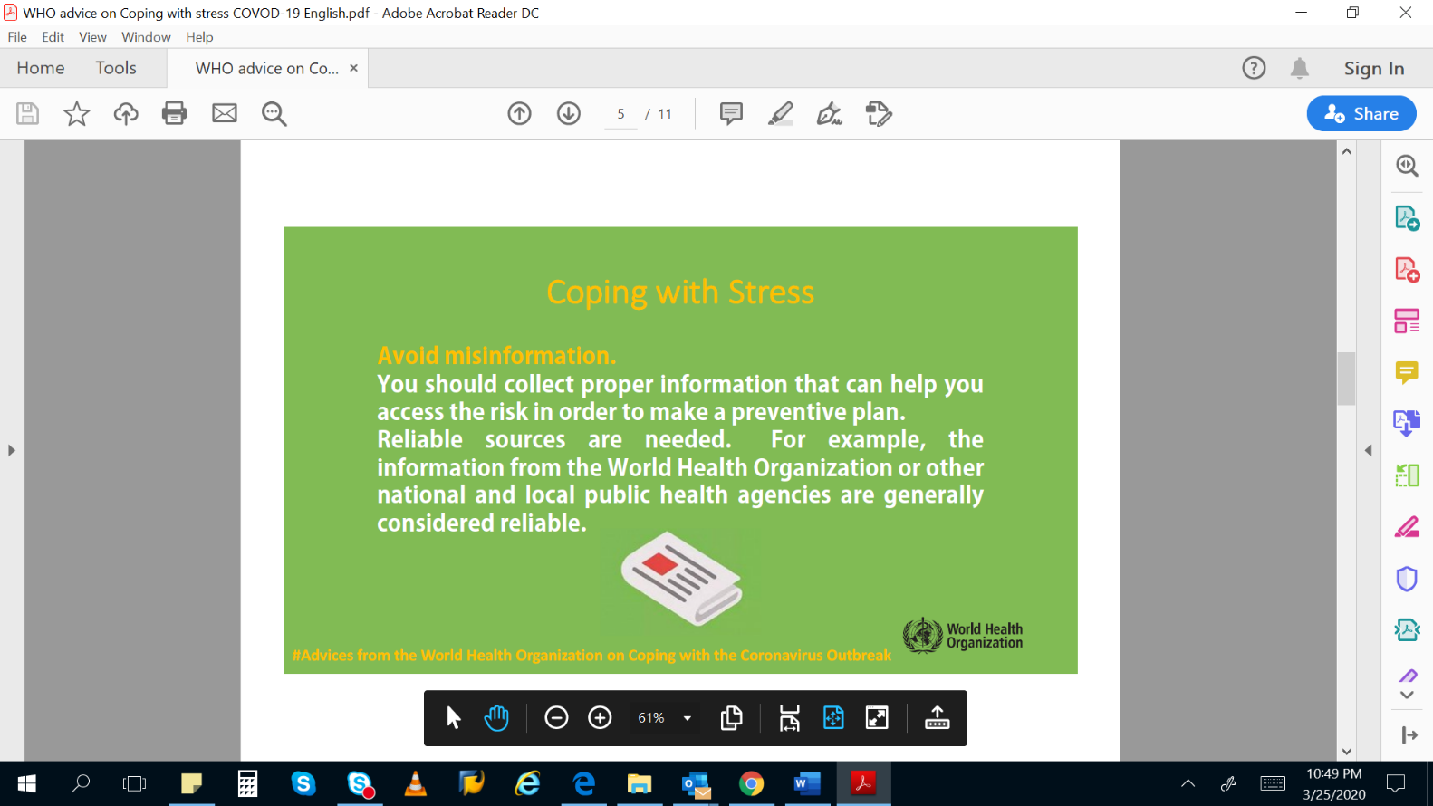

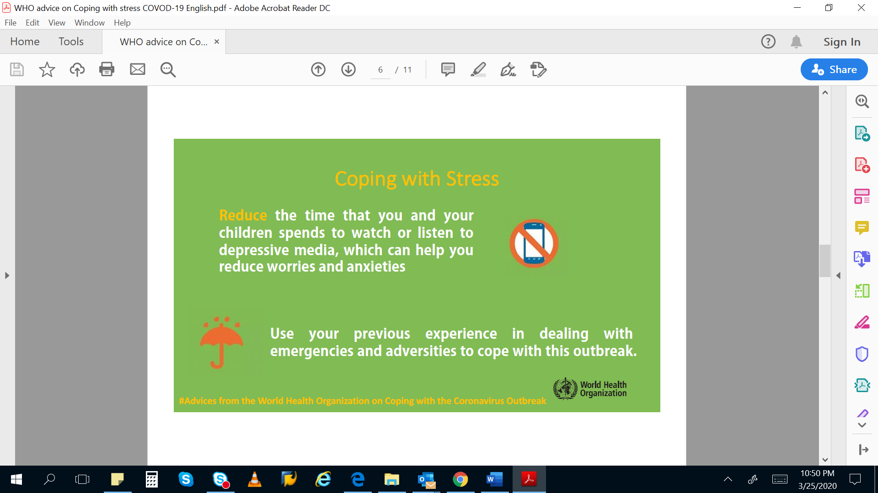

**How to reduce violence?**

Violence against women and children go up in times of stress and anxiety. Girls can be at increased risk of sexual violence. If you suspect violence, call the CHILDLINE Number (1098) or the National Women’s Hotline (1091). If you suspect that there may be trafficking of women or children or that a girl is being married below the age of 18, call these numbers or report to the police.

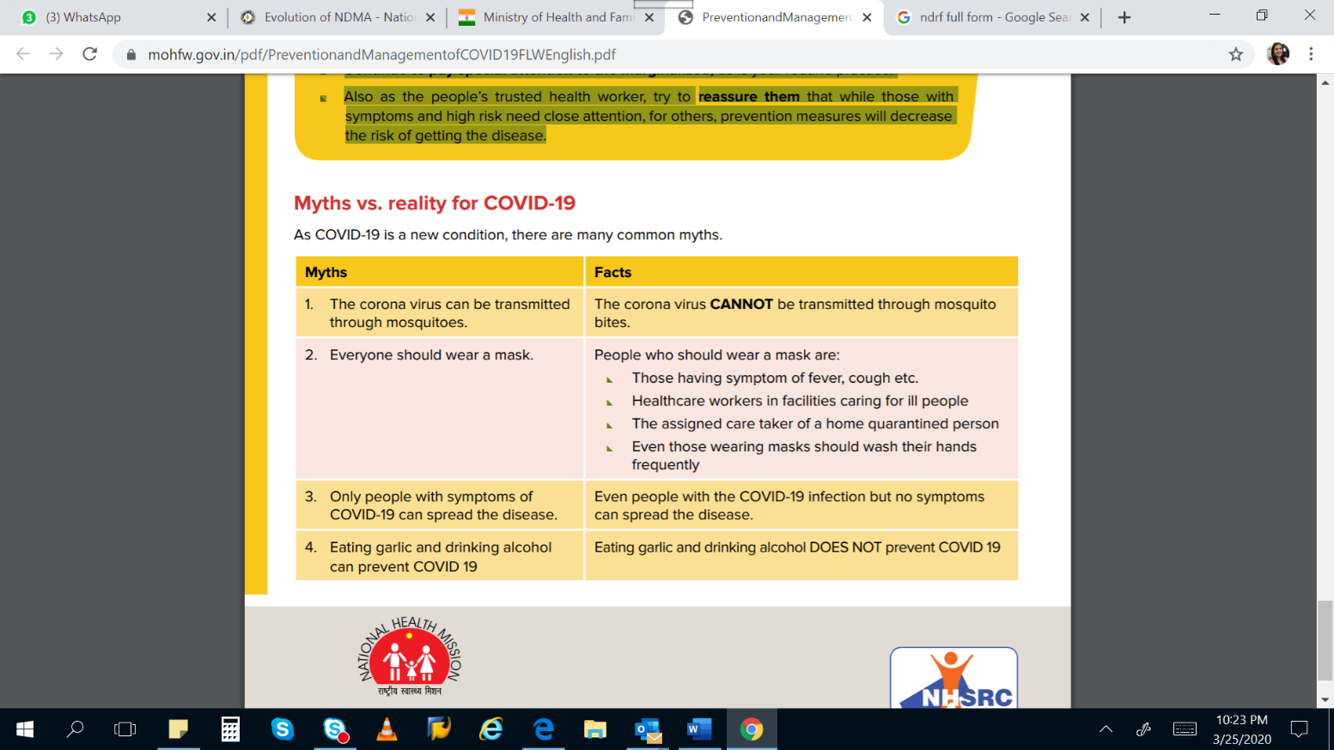

**FREQUENTLY ASKED QUESTIONS (FAQ)**

**What can I expect to experience from people during COVID-19?**

* Fear and anxiety
* Loneliness, boredom, sadness
* Anger, frustration or irritability
* Increased violence against women and children

It’s ok to feel a range of emotions, and distress is normal in this time. However, violence is never an acceptable response. Set an example by speaking calmly and kindly and by using non-violent, peaceful means to make your point. If you see people being violent towards one another, intervene and support them to de-escalate into a dialogue. If you see violence against women or children or other vulnerable persons, including those with disabilities, call the national hotlines (1098 for children, 1091 for women) or report to the police.

**Let’s be kind to yourself and others*.***

Kindness makes us and others feel better. Deliberately practice being compassionate and speaking calmly and respectfully even with persons who are agitated and shouting. An angry person is more likely to stop shouting when people around them quietly and calmly.

**Stigmatization**

Fear can make us self-focused sometimes and we can hurt others through stigma. It is important to respect each other especially now, and to show care for those both infected and affected.

**Remember that Preparedness facilitates Resilience.**

Resilience is the capacity to engage and disengage: we need to figure out how to engage with the issues arising from the COVID-19 when we need to, and how to disengage in order to give ourselves time to rest and recover from the stress, so that we don't burnout! Keep this in mind during your day.

**Reflect on past successes. Get confident about your coping and adapting skills*.***

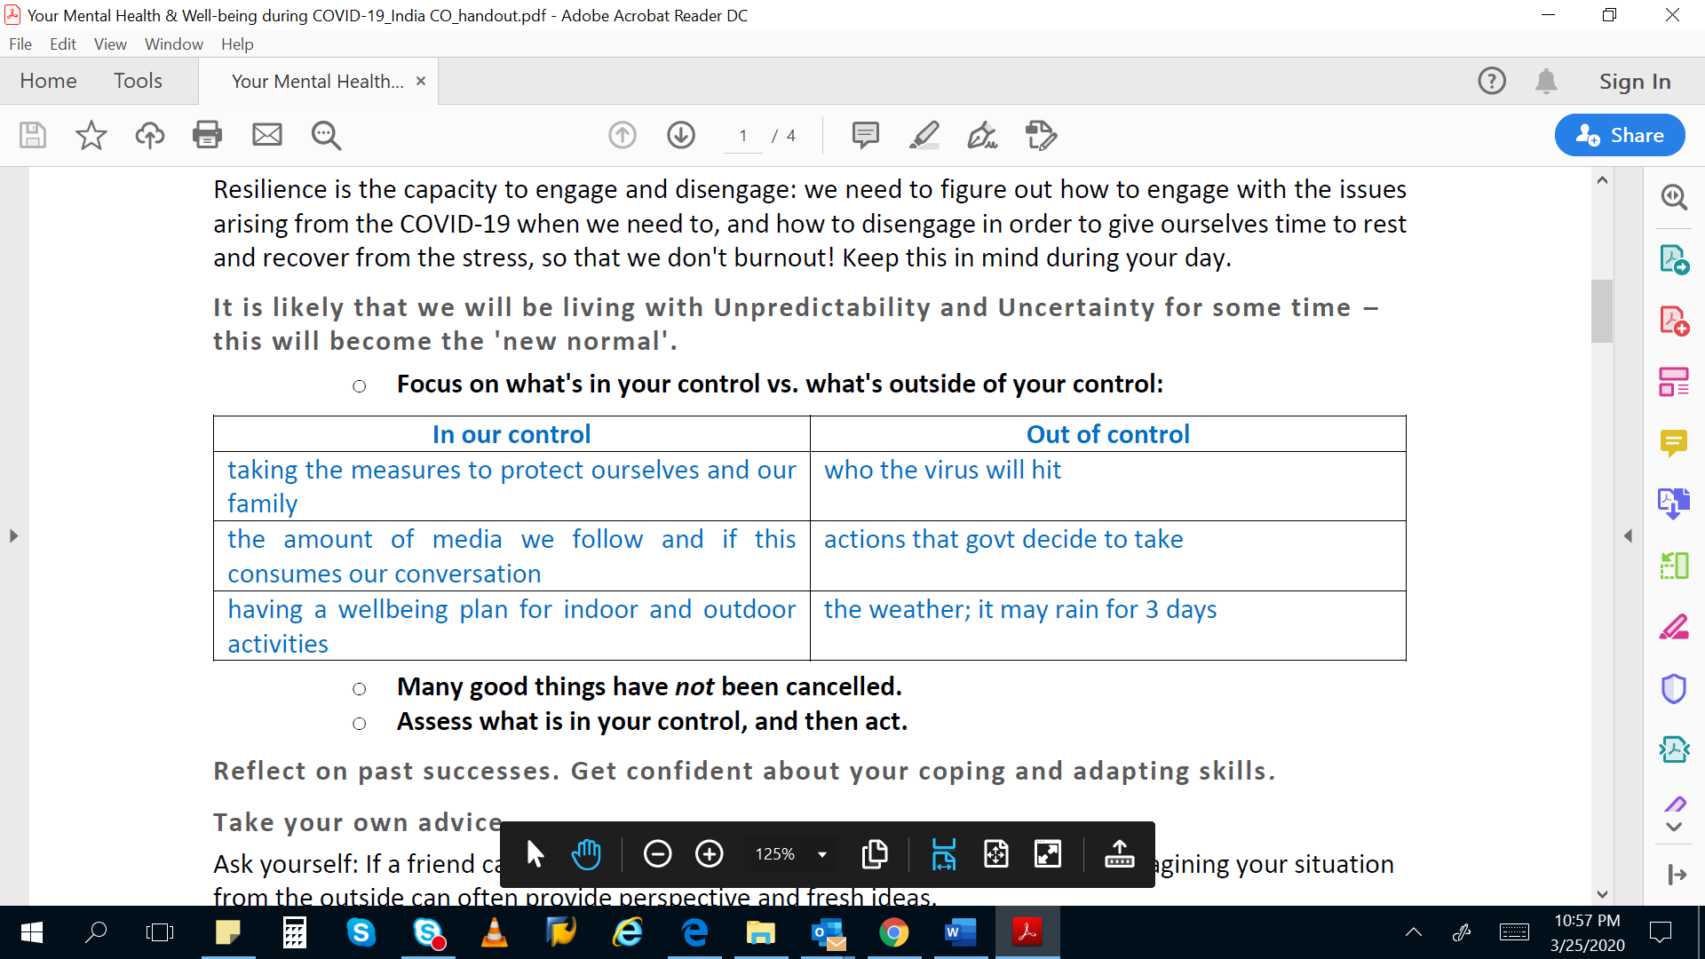**Take your own advice.**

