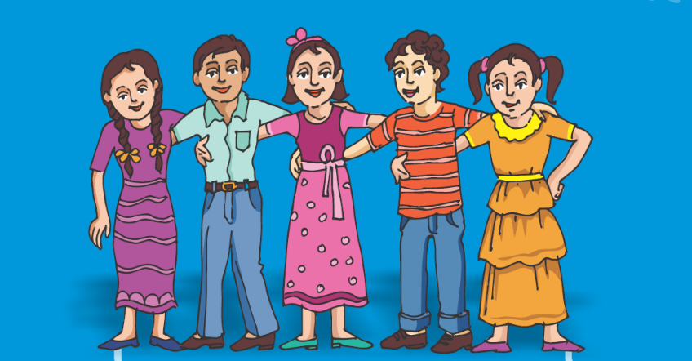
Covid-19 package for Adolescents & Youth

Why ?
This package has been developed and adapted from UNICEF and WHO guidance and protocols for promoting the well being and engagement of adolescents and youth in West Bengal during the COVID 19 pandemic. It consists of tools required by young people to keep themselves and others safe from the infection, deal with mental health and issues of online violence, as well as enable them to take appropriate action for response and handle stigma and discrimination in their families or communities. The purpose of this package is to provide practical guidance to adolescents and youth on various issues pertaining to their physical and mental well- being while enabling them to emerge as change agents for containment of the pandemic.

For whom ?
- School students
- Kanyashree Club/ SAG/ Meena manch other adolescent group members
- Youth club members

How?
Whatsapp versions of the materials can be circulated among adolescents and youth members of different groups using digital platforms and the posters can be physically displayed in places like youth clubs, chools, anganwadi centers etc.

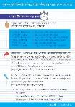
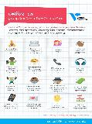
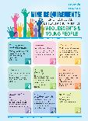
This pack contains :
- Booklet on mental health and psychosocial care
- Nine principles of adolescents & youth participation
- Online safety guidelines (Set of 2 posters)
- What adolescents & youth can do (Set of 3 posters)
- Important reminders for adolescents & youth
- How to combat discrimination
- Covid 19- Youth actions

