Toolkit to spread awareness and take action
on COVID-19

A note for UNICEF colleagues:

This document contains a range of practical actions that young people can take during the COVID-19 outbreak to raise awareness and understanding, stop the spread of misinformation, stigma and discrimination, and show support and solidarity. Many of these actions are already being taken by young people across the world.

This document is intended for COs to translate/localize and share directly with their youth networks (volunteers, schools clubs, young reporters etc.), and/or via their social media/digital platforms. Each UNICEF office should review the information and amend or remove content if not appropriate for their local context. This document was developed by the Division of Communication, with support of the Adolescent Development and Participation Team, Communications for Development and the Global Volunteer Initiative.

We hope to update this document regularly to include experiences and ideas from you and directly from young people. Please contact Katarzyna Pawelczyk if you’d like to share any feedback and ideas: kpawelczyk@unicef.org A digital version of the guide will be available on Voices of Youth shortly.

Please also consult the Practical Tips for Adolescents and Youth in the COVID-19 Response under the Risk Communications and Community Engagement Pillar.

Links to the Toolkit and supporting resources
- A public version of the Toolkit is available here (in English).
- Social media assets to promote the toolkit are available on WeShare.
- Design files are available via WeShare.
- The toolkit is also available online as a webpage on Voices of Youth.

- Why your help matters

All around the world, people are taking necessary steps to protect themselves and their families from the new coronavirus disease (COVID-19), to support their communities, and prevent the spread of the outbreak.

Unfortunately, while many people are sharing information about the virus and how to protect against it, not all of it is correct. Misinformation and a lack of information during a health crisis can spread paranoia, fear, and stigma, and result in people not being protected or doing things that can hurt themselves and others.

The outbreak has also left many people feeling worried, isolated, lonely and stressed. More than ever, we all need to raise awareness, build solidarity, support each other, and be kind.

As a volunteer, club member, young advocate, young reporter or concerned citizen we know that you are passionate about making the world a better place for children. Many of you are probably already taking action to prevent the spread of COVID-19.

Inspired by the actions of young people across the world we’ve compiled a set of actions that anyone can take to join the fight against misinformation and stigma, and to promote community support and spirit.

We want this to be a living document that is regularly updated with your ideas, recommendations and experiences. If you have suggestions on how we can improve it please send them to us via ______________[Each office to insert details or remove if not appropriate]

For more information about COVID-19 visit the UNICEF website.

- How you can help

Before you take any actions please read section 3 which covers all the important things you need to know before getting started.

Actions under 2 mins
- FOLLOW UNICEF and the World Health Organization (WHO) on Facebook, Twitter, Instagram for the latest information and updates. [Each office to insert locally relevant links]
- SHARE the social media messages and graphics from UNICEF and WHO with your Facebook, WhatsApp, TikTok, Snapchat, Instagram, Twitter (or any other social media you use) to make sure that all your friends have correct and reliable information! You can also share links to UNICEF’s information in any online forums or comment sections on websites that you visit regularly.
- Sign up for U-REPORT to get the latest updates in your country and to learn how to protect yourself. The U-Report COVID-19 Information Chatbot provides vital information about COVID-19 and challenges myths including through ‘rumor tracking’. To check it out do the following:
  - WhatsApp: Send “CoronaVirus” to +66 80 024 9442.
  - Facebook Messenger: Send ‘CoronaVirus’ using Facebook Messenger at http://m.me/UReportGlobal
  - Viber: Follow ‘U-Report’ Public Account on Viber (Go to Discover), Send the message ‘CoronaVirus’

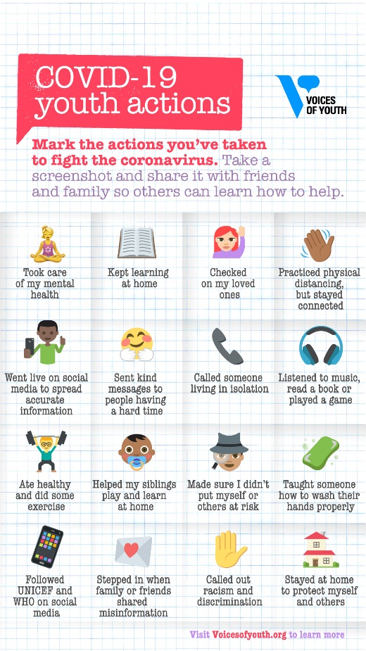
BONUS! Save this image and mark all the actions you’re taking to fight the coronavirus. Then share it on social media and ask your friends to do the same. [This image is available via this link in English. The graphic is also available in Spanish and a blank template is available for offices who wish to translate it into other languages]

Actions that take 5-15 mins
- TEST your knowledge. Do you know the facts about COVID-19? Take the UNICEF quiz to find out. Then challenge your friends to take it.
- Check out VOICES OF YOUTH for stories, poems, drawings and comics by young people about their experiences with the COVID-19 outbreak. Sign up and share your story or creative content, or engage with Voices of Youth on Twitter.
- GO LIVE on social media and show people how to wash their hands correctly and/or talk about the importance of physical distancing. Make sure you have the correct information before you share it with others – you can find a lot of resources on UNICEF’s website. You could also take part in one of the many local and global social media challenges happening to promote health and safety around COVID-19 or to boost people’s spirits.
- DO A TUTORIAL: If you have a skill or a hobby that you can do safely from home (dancing, cooking, poetry, fitness, art) you can also share that with friends online to brighten up their day - and yours.
- INTERVENE when you hear or see family sharing misinformation or making discriminatory/xenophobic comments – in person, on social media or even in the family WhatsApp group. See the next section for tips on how to do that!

Actions that take 15 mins or more
- TALK TO YOUR FAMILY: Make sure that all your family members know the importance of handwashing and hygiene, physical distancing and where to find the latest, most reliable information. Set up a family meeting to discuss this with them. If you have family who don’t live with you or don’t have regular access to reliable news sources, pick up the phone and give them a call. This is especially true of grandparents (people over 70) and others who are more vulnerable.
- HELP WITH LEARNING & PLAY: Find out if you can help younger siblings or family members with learning and play activities if their schools have closed,.
- STUDY BUDDIES: If your school or university has closed, team up (virtually) with a friend or group of friends to study together or help each other with course material. Adjusting to the learning remotely can be challenging for a lot of people and they may not feel comfortable asking for help.
- COMMUNITY SPIRIT: Organize a remote or virtual activity with your friends, family or neighbors to show solidarity and support during this challenging time. In some countries people have been organizing sing-alongs or playing musical instruments with their neighbors – while staying safe in their own homes.
- COMMUNITY NEEDS: You might already be part of a community group – if so, you can work together to understand how community members feel at this time, what their needs and what they are worried about. You could use community WhatsApp groups, Facebook pages, listservs, message boards or even phone calls to consult people and compile a list of community concerns and needs. These can be shared with local leaders to help them respond. If you are not part of an existing community group find out which groups are already doing something. And remember to stay safe and avoid close contact with other people.

How to take action if someone promoting discrimination
There is no excuse for discrimination or xenophobia during a disease outbreak – or in any situation. COVID-19 can affect anyone and everyone – regardless of where they come from, what they look like, or how old they are. Migrants and refugees are among the most vulnerable groups. COVID19 does not discriminate, nor should our response.

What to do if a family member or friend is saying something discriminatory:
- Once again, approach them privately first – in person or via direct message. They are more likely to be receptive if they don’t feel publicly embarrassed.
- Point out to them that viruses can affect anyone and everyone, and that this is not about one group of people.
- Point out to them that singling out one group of people and blaming them for the virus could have very serious consequences – it might encourage violence and prevent people from seeking medical care when they need it, which will further spread the disease.
- Remind them that at times like this we need to support one another and promote kindness and compassion – even if we are scared.

How to take action if someone is spreading misinformation
Many people are worried and anxious right now – and in difficult times people sometimes share incorrect or inaccurate information. Often, they are not doing this on purpose and are trying to be helpful – they simply don’t know where to find the correct information.

What to do if a family member or friend is spreading misinformation:
- You may want to approach them privately first – in person or via direct message. They are more likely to be receptive if they don’t feel publicly embarrassed.
- Don’t accuse them of spreading misinformation. Instead point out to them that the story or advice they shared doesn’t look like it came from a trustworthy source OR that it is not the most accurate.
- Point them to reliable and trustworthy sources like UNICEF and the World Health Organization and encourage them to follow these organizations for up-to-date and accurate information.

- Important reminders before you start

- Health first: do not put yourself at risk in any way. Make sure you follow local guidance regarding the types of activities that are permitted during the outbreak. Mental health self-care is essential – take care of yourself, and if you are able to, help support others. If you’re feeling overwhelmed, anxious or worried, first know that you are not alone. Find someone you can talk to about how you are feeling – find a family member, a friend, a colleague, a counselor or anyone you feel comfortable reaching out to and speaking with. See the end of this document for a list of support resources and share it with others in your network.
- Online safety: if people online become aggressive or behave like trolls do not engage with them. Block them and report them if necessary. Check out more online safety tips here.
- It’s okay to be unsure: if someone asks you a question about COVID-19 and you’re not sure, don’t guess. Say that you don’t know and refer them to UNICEF and WHO or local government authorities for the most detailed and up-to-date information.
- Don’t keep it to yourself: if you are worried about something that has happened or that you’ve seen contact your local UNICEF focal point. [Each office to insert details]
Tell us what you’re up to!
We’d love to hear how you’re helping to prevent the spread of the COVID-19 or adjusting to the changing way of life.
Get in touch with your local UNICEF office or you can share your story with UNICEF’s Voices of Youth (in English, Spanish, French and Arabic), through the website, or on social media using the hashtags #voicesofyouth and #VolunteersForChildren

- Resources

[Each office to insert appropriate local language resources]

UNICEF Resources on COVID-19
- UNICEF COVID-19 portal
- A handwashing demonstration by UNICEF Executive Director Henrietta Fore

Mental Health Resources
- UNICEF article on how teens can protect their mental health during COVID-19
- VIDEO: Q&A on COVID-19 & mental health from WHO
- Voices of Youth blog by a young mental health advocate
- Mental Health resources from MHIN
- Mental Health and Psychosocial Support Resources During the COVID-19 Pandemic

