COVID-19: CHILDREN AT HEIGHTENED RISK OF ABUSE, NEGLECT, EXPLOITATION AND VIOLENCE

NEW TECHNICAL GUIDANCE TO HELP STRENGTHEN PROTECTION MEASURES FOR CHILDREN DURING PANDEMIC
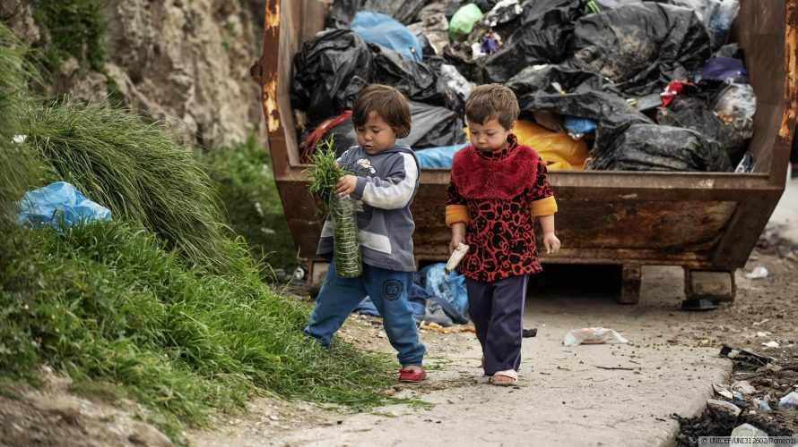Children play in the Reception and Identification Centre in Moria, on the island of Lesvos, in Greece. The situation for refugee and migrant children on the Greek islands remains dire and dangerous.
NEW YORK, 20 March 2020 – Hundreds of millions of children around the world will likely face increasing threats to their safety and wellbeing – including mistreatment, gender-based violence, exploitation, social exclusion and separation from caregivers – because of actions taken to contain the spread of the COVID-19 pandemic. UNICEF is urging governments to ensure the safety and wellbeing of children amidst the intensifying socioeconomic fallout from the disease. The UN children’s agency, together with its partners at the Alliance for Child Protection in Humanitarian Action, has released a set of guidance to support authorities and organizations involved in the response.
In a matter of months, COVID-19 has upended the lives of children and families across the globe. Quarantine efforts such as school closures and movement restrictions, while considered necessary, are disrupting children's routines and support systems. They are also adding new stressors on caregivers who may have to forgo work.

“IN MANY WAYS, THE DISEASE IS NOW REACHING CHILDREN AND FAMILIES FAR BEYOND THOSE IT DIRECTLY INFECTS”
Stigma related to COVID-19 has left some children more vulnerable to violence and psychosocial distress. At the same time, control measures that do not account for the gender-specific needs and vulnerabilities of women and girls may also increase their risk of sexual exploitation, abuse and child marriage. Recent anecdotal evidence from China, for instance, points to a significant rise in cases of domestic violence against women and girls.
“In many ways, the disease is now reaching children and families far beyond those it directly infects,” said Cornelius Williams, UNICEF Chief of Child Protection. “Schools are closing. Parents are struggling to care for their children and make ends meet. The protection risks for children are mounting. This guidance provides governments and protection authorities with an outline of practical measures that can be taken to keep children safe during these uncertain times.”
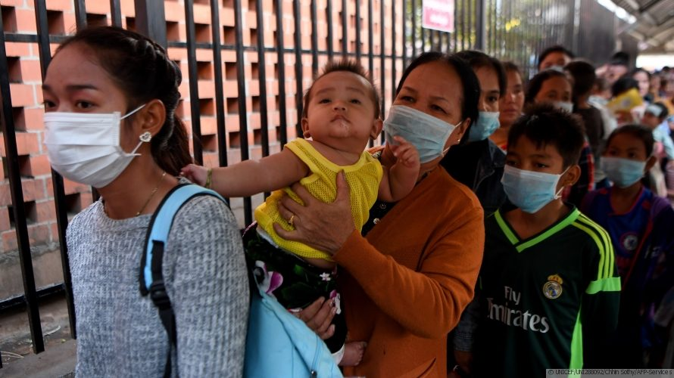People wear face masks as they wait to enter a children's hospital in Phnom Penh, after the first case of novel coronavirus was reported in the country.
Increased rates of abuse and exploitation of children have occurred during previous public health emergencies. School closures during the outbreak of Ebola virus disease in West Africa from 2014 to 2016, for example, contributed to spikes in child labor, neglect, sexual abuse and teenage pregnancies. In Sierra Leone, cases of teenage pregnancy more than doubled to 14,000 from before the outbreak.
As part of the guidance, the Alliance is recommending that governments and protection authorities take concrete steps to ensure protection of children is integral to all COVID-19 prevention and control measures, including:
- Train health, education and child services staff on COVID-19 related child protection risks, including on the prevention of sexual exploitation and abuse and how to safely report concerns;
- Train first responders on how to manage disclosure of gender-based violence (GBV Pocket Guide), and collaborate with healthcare services to support GBV survivors;
- Increase information sharing on referral and other support services available for children;
- Engage children, particularly adolescents, in assessing how COVID-19 affects them differently to inform programming and advocacy;
- Provide targeted support to interim care centres and families, including child-headed households and foster families, to emotionally support children and engage in appropriate self-care;
- Provide financial and material assistance to families whose income generating opportunities have been affected; and
- Put in place concrete measures to prevent child-family separation, and ensure support for children left alone without adequate care due to the hospitalization or death of a parent or caregiver; and,
- Ensure the protection of all children is given the utmost consideration in disease control measures.

