Government of Madhya Pradesh – Effective delivery of psycho social support for children during COVID 19
Background:
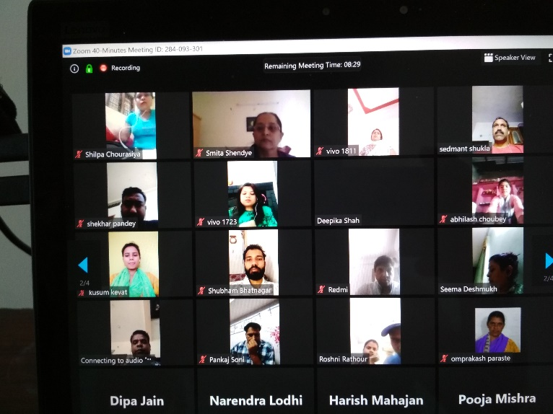
COVID 19 has affected the entire world and the consequent lockdown has further affected human life style. The situation is grim because there has been loss in many ways, separation, suffering and death. Restriction on freedom of movement has adversely affected everyone. Economic stress, particularly for the poor and the lower middle class is immense. In the midst of all these chaos, children are the most affected, both physically and psychologically. They are scared of the virus for themselves and for their family members, they are anxious because they are out of school, and they are not able to meet their friends; they cannot go out to play or hang around. Further, they are also victims of the stress and abuse played out in the family space because of the growing anxiety. Their social connect is limited to online engagements; this also pauses many risks to children.
Strategy and Interventions:
In this challenging circumstance, Government of Madhya Pradesh (GoMP) in partnership with UNICEF rolled out the Psycho Social Support programme for Children. UNICEF with GoMP had during 2018-19 had capacitated a group of about 108 counsellors from District Child Protection Units, Chidline, Child Care Institutions and CSOs, with technical support from National Institute of Mental Health and Neuro Sciences (NIMHANS), Bangalore. As COVID 19 struck the state, among them 69 counsellors were further trained online to provide effective counselling support to children and equipped them with technically sound information on COVID 19. They were also briefed about the ethics of counselling over telephone or via online. They were assigned to all the 52 districts of the state, to support children in child care institutions and community settings, including children of migrant labour families to provide counselling support. The administration of the institutions were briefed of the protocols of providing PSS to children in the Homes, and contact numbers of the counsellors were shared across various networks, departments and agencies working with children within the state so that their services are sought.
Outcome:
The outcome of this engagement was very empowering. The counsellors conduct one to one counselling sessions and group sessions. The individual counselling sessions are mostly conducted via telephone call or whatsapp video call, while the group sessions through video call and WhatsApp call. They impart the information on COVID 19, safety measures including handwashing and social distancing, as well as bust certain myths and misinformation among children and the care givers. More importantly, they help children to address their anxiety and stress. Some of the issues that children have discussed with the counsellors include fears about infection to themselves, family members and friends and about death, fear on account of the breakdown of school, anxiousness on account of their inability to meet and play with friends; problems at home; etc. The counsellors through group sessions have been able to conduct various creative activities in the CCIs. Children have developed posters, paintings, poetry songs, theatre activities on the theme of COVID as well as other issues. These engagements have created a positive environment in the institution and children have been creatively engaged. Handwashing is done in a creative manner. Technology is used very effectively by the CCIs to engage with children, virtually. On account of the regular engagement of the counsellors, monitoring of the CCI and addressing any issues children face has also been more effective. Any challenges that children face has been brought to the attention of the District level authorities and sorted out, including about food/menu, supply including that sanitation materials and medicines etc. There are also few instances where the staff of CCIs take psycho-social support of counsellors.
Crisis intervention and counselling support to Mother and Child in case of Domestic Violence
Karon is married to love of her heart for the twelve years. She had inter-religious marriage; she a Christian had married a Hindu. Life spanned smoothly for three years, till her son was born. Her husband started drinking and gradually was addicted to alcohol, and he would be irritated and turn violence for no reason. Karon, a post graduate, with a Bed qualification worked in different schools as teacher, with breaks from time to time, on account of violence outbreaks at home. She continues to support her child’s education, and he is studying in class 5.
During the COVID lockdown, her husband was stuck at home and the situation became much worse. He frequently troubled her for money to buy liquor, which was available through illegal suppliers at a much higher price. started troubling her for money to buy liquor, abused her and the child physically and mentally. On the night of 27th March he forced her to go the ATM to draw money from her account for buying liquor, and when she refused she beat her up badly and threw her and her son out of the house. Finding no other place to go she went to her friends’ place and the friend called up Child Helpline.
Child Line and a local organization Awaj took up the matter coordinated between One Stop Centre, and the Police. Childline coordinated with the District Programme Officer and supported their stay at the Government Night Shelter and facilitated in registering a police case and it also counselled the mother and the child. The following morning, she moved to her elder sister’s home with the child. Childline has continued to interact with the mother and child and provide counselling support to both of them. The mother is holding strong, to decide future course of action, after the lockdown.

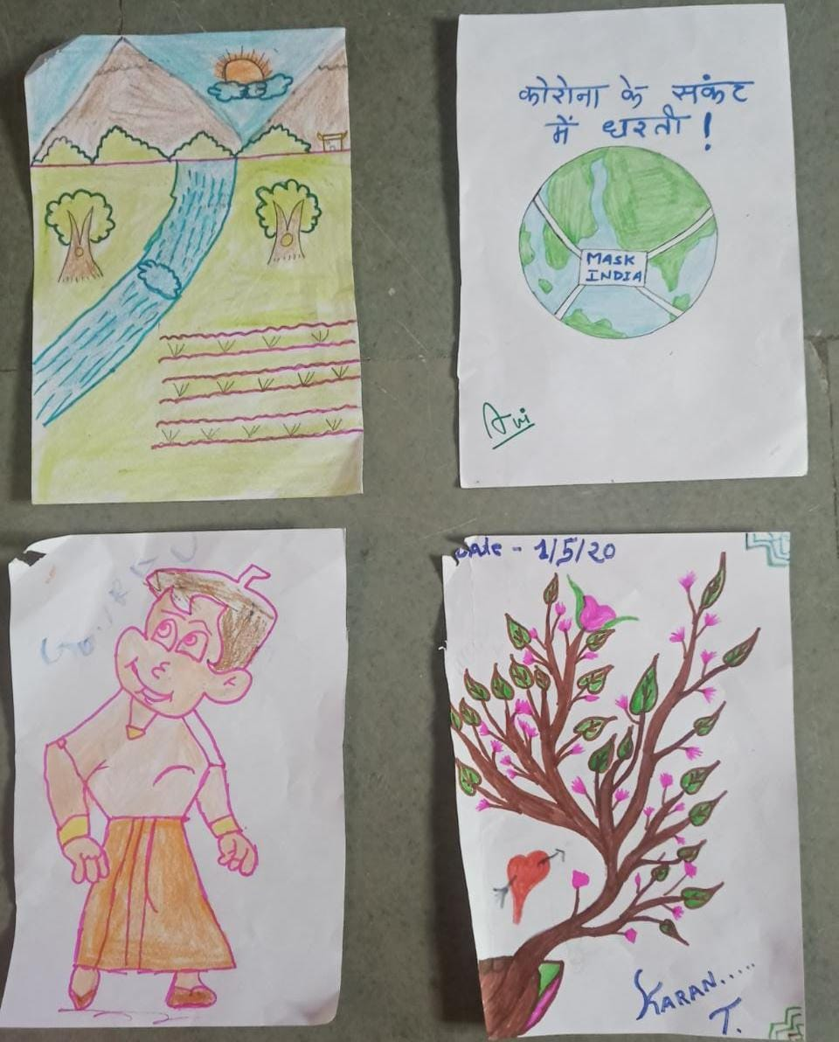
During the last 3 weeks, since the operationalization of this support service 2600 children (34% girls and 66% boys) have been supported with counselling service. Among them 739 children have sought individual counselling support and 1861 children have received group counselling support. In addition over 98 adults have been supported with psycho-social support by counsellors.
Key Learnings and Next Steps:
It is extremely critical to provide counselling support to children both at normal times, and more especially during difficult times, such as this. However, children do not generally need very complex counselling support. They need a friendly and re-affirming person to listen to them, to talk to them and re-assure them. Their fears need to be addressed and they need to be provided with correct information. They also need someone who they can clarify their doubt and fears. Overall, the counsellor is a person who they can trust and feel good. This experience is also revealing that bare-foot counselors can do wonders. Most counsellors assigned to children are not academically qualified counsellors, but individuals who have experience of working with children and have gained sensitivity and commitment to children. They are also individuals who have a great sense of empathy.
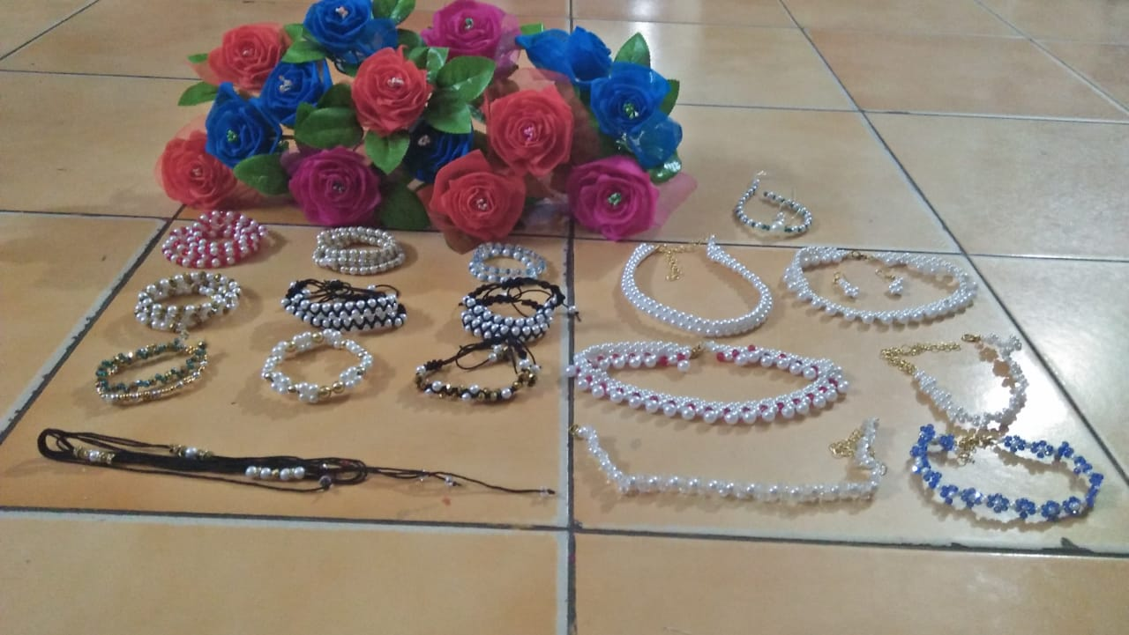
The Department of Women and Child Development with UNICEF and NIMHANS carries out refresher and reiview programmes with the pool of counselors on 2-3 week basis, which will address some of the implementation challenges. The counselors maintain their daily case diary and daily report. They submit their weekly report on specified proforma. Whatsapp group is used as a medium for the counsellors to share their experiences, concerns and achievements. The Counsellors have expressed their great sense of satisfaction and fulfilment in being part of this venture. Some of them are in fact peer-counsellors to the other.
Products made from waste materials by children
It is agreed between GoMP and UNICEF to sustain this programme and strengthen the counsellors through refreshers and mentoring programme.

