Work-Book
ADOLESCENT WELLNESS PROGRAM

Dr. E. Aravind Raj
Dr. Kavita V. Jangam
Dr. Upasana Baruah
Mr. Muthukumar
Mr. Shahid Iqbal
Ms. Mamata

Department of Psychiatric Social Work
NATIONAL INSTITUTE OF MENTAL HEALTH AND NEURO SCIENCES
(Institute of National Importance),
BENGALURU-560029

DEPT OF PSYCHIATRIC SOCIAL WORK
NATIONAL INSTITUTE OF MENTAL HEALTH AND NEURO SCIENCE
BANGALORE - 560029

ADOLESCENT WELLNESS

Participant Profile

Name: ………………………………………………….. Age:…………. Sex: Male / Female
Department:.…………………....................................…………………………………………
Address:……………………………………………………………….....…………………….
………………………………………………………………………….....…………….............
Phone: ……………………….…...e-mail: …………………………..........................................
Educational Qualifications:……………………………………………………….....………….
Designation:…………………………………………………….....……………………………
Years of Service in the Organization:…………………………………………....……..………
Have attended previous training program on the area of “Psychosocial care”? Yes/ No
…………………………………………………………………………………………………………………………………………………………………………………………………….
Briefly mention your expectations from this training program:
……………………………………………………………………………….....……………………………………………………………………………………………………………………………………………………………………………………………………………………

Date: …………. Signature: …………………………..

Experience Sharing

Bio-Psycho-Social model

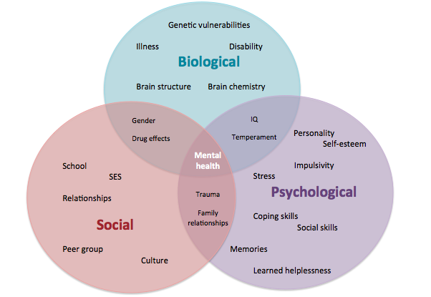

Development of Adolescents
Aim: To understand the normal development of adolescent

10 – 13 years
(Male)
Physical | Social
COGNITIVE | EMOTIONAL

10 - 13 years
Female
Physical | Social
Cognitive | Emotional

13 – 19 years
(Male)
Physical | Social
COGNITIVE | EMOTIONAL

13 - 19 years
Female
Physical | Social
Cognitive | Emotional

Needs of the adolescents
Aim: To understand the psychosocial needs of adolescents in different levels

Gender, sex and sexuality
Aim: To understand gender related issues of adolescents

Life of River
Boys | Girls

Sexual Development and Needs

Adolescents (11 to 19 years)
Development | Needs
Body Mapping

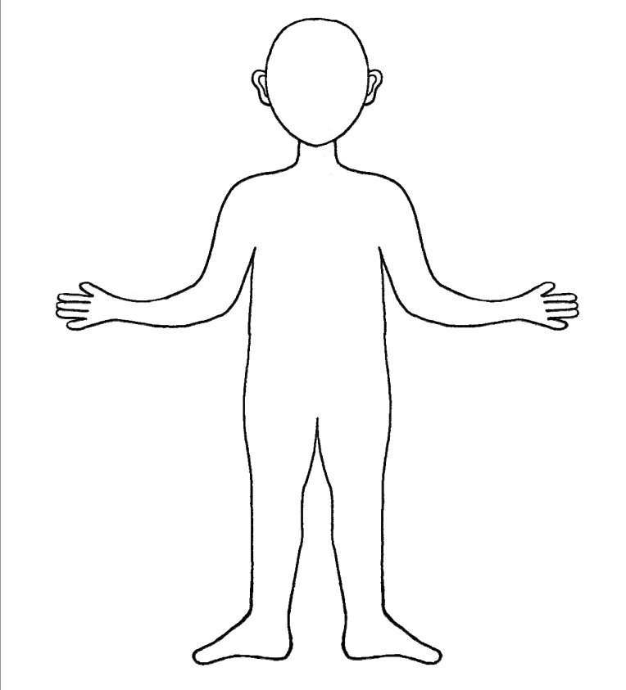

Sexuality related concerns of adolescents

Nocturnal wetness

Menstruation

Sexual preference

Pregnancy

Concerns of adolescents
Aim: To understand the common Issues of adolescents (Brainstorming & Discussion):
- Substance use
- Teenage pregnancy
- Relationship issues
- Academic issues
4 groups will be given the topics as mentioned above and ask them to list out the points in terms of:
Causes of the issue | Impact of the issue | Psychosocial consequences

Management of Emotional and Behavioural Problems among adolescent

CASE STUDIES ANALYSIS
Case study 1:
Anil is 13 years old boy lives with his mother. Since the parental separation, child has to visit the father on holidays. The father is hostile towards mother and displaces his anger on the child. The child is not given to go for school trips and other activities by the father. As a result, child refused to go to father’s house in the holidays, but was forcefully taken. This resulted in the child being aggressive towards the mother and consequent school dropout.
Discussion:
- Identify the emotional (internalizing) & Behavioural (externalizing) issues of the child?
- Establish the context of this issue?
- what are the psychosocial factors which has contributed to this issue?
- How to manage?

Case study 2:
Rita, a 15 years old girl was seen with the problems of decreased social interaction, reduced food intake and significant decline in academic performance. On assessment the child reveals experiences of bullying in school with regards to her appearances (colour & weight) along with social exclusion among her peer group.
Discussion:
- Identify the emotional (internalizing) issues of the child?
- What is bothering the child (psycho social factors) in this case?
- How to manage this issue?

Case study 3:
Raja, a 12 years old boy was seen with problems of not obeying mother, not following the instructions of teachers in school and demanding for expensive things to the mother. The parents of the child always have discord. The father is permissive towards the child and allows him to do as he wishes. The mother is often disciplining the child. The child shows verbal aggression towards the mother, following which, the mother meets the child’s demands.

Discussion:
- Identify the emotional (internalizing) & behavioural (externalizing) issues of the child?
- Establish the context of the issue?
- Identify the psycho social factors in this case?
- How to manage this issue?

Case study 4:
Rani, a 15 years old girl was seen with problems of deliberate self-harm by often slashing her wrist with sharpens. Her parents always had very high expectations of her academic performance as the child had always been the class topper. Since the child’s relocation to another city during her 9th grade, the child was not able to secure the same rank as her previous school due to increased competition. Additionally, the child's parents also were critical towards her. As a result, child's academic performance in the following year declined and she was also introduced to cigarette smoking by her peer group.

Discussion:
- Identify the emotional (internalizing) & behavioural (externalizing) issues of the child?
- Establish the context of the issue?
- Identify the psycho social factors in this case?
- How to Manage this issue?

Case study 5:
Mala, a 13 years old girl was sexually abused by her teacher in the school. It was a severe form of sexual abuse. Since then, the girl is very disturbed. It has been two years since the incident has taken place. Even now, she is fearful of men and strangers. She often cries without any reasons and talks about the incident to her mother. She is scared to sit in school and gets aggressive with other children. She beats up teachers and other children when she is upset. Sometimes she says she should die and she is good for nothing. She feels people will abuse her again when she alone. She is scared of being alone and being in the dark. When she is upset, she has a bedwetting due to scary dreams.

Discussion:
- Identify the emotional (internalizing) & behavioural (externalizing) issues of the child?
- Establish the context of the issue?
- Identify the psycho social factors in this case?
- How to Manage this issue?

Working with Adolescents
Aim: To understand the basics of counselling techniques while working with adolescents

Rapport building:
Getting to know the person | Introducing yourself

Active listening:
…………………………………………………………

…………………………………………………………

…………………………………………………………

…………………………………………………………

………………………………………………………………………………………………….

Empathy

Communication with adolescents:
Do’s | Don’ts

Encouraging expressions of emotions:

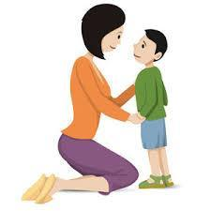
--------------------------------------------------------------------------------------------------------------------------------------------------------------------------------------------------------------------------------------------------------------------------------------------------------------------------------------------------------------------------------------------------------------------------------------------------------------------------------------------------------------------------------------------------------------------------------
Observation
verbal responses:

nonverbal behaviour

emotions

physical appearance

Developing hobbies and interests:

Relaxation & recreation:

WORKSHEET- DOs AND DON’Ts IN COUNSELLING

Instructions: The following are the statements related to counselling. Kindly read it carefully and please circle the correct response for each statement.

S. No | Statements | True | False
1 | Counselling is most effective when you empathize with the student | T | F
2 | Making notes on a piece of paper while listening to the student is good for the skilled teacher’s memory and makes the student knows that the teacher is listening to him/her | T | F
3 | If the student is giving incorrect information, the trained teacher should immediately check the student before he/she makes any more mistakes | T | F
4 | It is important that the student feels listened to | T | F
5 | Always greet the student before starting the session | T | F
6 | Do not look at the student during conversation as that can be impolite | T | F
7 | Tell the student during what is wrong and right instead of sharing the correct information with him/her | T | F
8 | Be polite with the student | T | F
9 | Introduce yourself, your organization and its work | T | F
10 | Be Judgemental |  | F
11 | Make promises that you cannot keep | T | F
12 | Impose your own solutions on the student | T | F
13 | Be precise and clear | T | F
14 | Show sympathy to the student | T | F
15 | Be punctual and always keep appointments | T | F
16 | Make the student feel comfortable | T | F
17 | Ask open-ended questions | T | F
18 | Always know your subject matter | T | F
19 | Give advice to the student | T | F
20 | Provide incorrect information | T | F
21 | Facilitate decision making process of the student | T | F
22 | Maintain eye contact with the student | T | F
23 | Interrupt the student while he/she is talking | T | F
24 | Intimidate the student through your body language | T | F
25 | Recap the conversation for the student | T | F
26 | Make the student feel important | T | F
27 | Use the appropriate strategies and skills | T | F
28 | Think that you can control the student’s behaviour | T | F
29 | Maintain confidentiality | T | F
30 | Share relevant counselling information with his/her parents/teachers | T
31 | Counselling is most effective if you provide counselling to your own students rather than other students | T | F
32 | The skilled teacher should be friendly rather than professional | T | F
33 | Students should be excused from academic responsibilities due to the problems | T | F
34 | Counselling can be done at anytime and anywhere | T | F
35 | The student can maintain a personal relationship outside the counselling setup | T | F
36 | Each session of counselling should be very structured and well planned | T | F
37 | Discussing trivial details unrelated to the student’s problems are important in counselling | T | F
38 | Voice of the trained teacher should be clear but soft | T | F
39 | The skilled teacher can force the student to say or do things that he/she may not want to do or admit | T | F
40 | If the student is agitated, the trained teacher should try to calm him/her before starting the session | T | F
41 | Self-disclosure of the teacher is always necessary | T | F
42 | The teacher can maintain a highly personal relationship outside the counselling setup. | T | F

Principles of working with adolescents

Non-Judgmental attitude

Confidentiality

Respect and dignity

Right to self determination

Best interest of child

Supportive environment

Life skills education for adolescents

Aim: To understand the importance and benefits of using core life skills in day to day life

- Self-awareness:

Who am I?

- Empathy

- Effective communication:

- Interpersonal relationship
Situation:
Ram is not in good terms with his parents. He feels they are too old and do not understand what he wants. He wants to spend time with friends and study along with them which parents do not approve of.
One day, Ram had a fight with his parents, because of the above-mentioned reason.
What you might have done if you are in his situation????

5.Creative thinking

6. Critical thinking

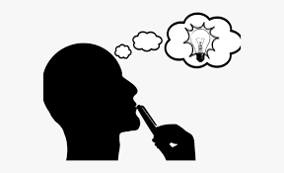

7. Decision making

8. Problem solving:

9. Coping with stress

10. Coping with emotion

Suicide prevention among adolescents- a gatekeeper approach

Who is a Gatekeeper?

Role of a Gatekeeper?

Understanding Suicide and Self harm:

Suicide | Self harm

Warning signs of suicide?

Risk factors?

Preliminary Suicide Risk Assessment: “IS PATH WARM?”
I
S
P
A
T
H
W
A
R
M
How to assess suicidal intent?

- Direct question?

- Normalizing question?

How and when to refer?
Risk level | Risk | Suicidality | Possible interventions
High
Moderate
Low

