**CP - Psychosocial and Mental health well-being of children during COVID-19 pandemic**

In the context of COVID-19, Child Protection focuses on: i) support standards of care, specially for those children separated from their families (temporarily or due to the loss of parents) or in Child Care Institutions (CCIs); ii) psychosocial support (PSS); iii) support RCCE efforts together with C4D; iv) prevention of violence. This note focuses on ii) PSS but touches on i) care and iv) prevention of violence. For overall global guidance use this [link](https://alliancecpha.org/en/system/tdf/library/attachments/the_alliance_covid_19_brief_version_1.pdf?file=1&type=node&id=37184).

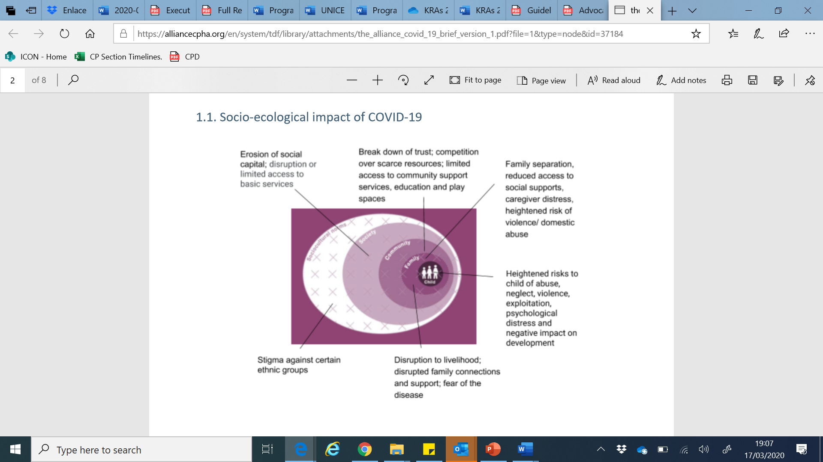It is natural to feel stress, anxiety, grief, and worry during an ongoing pandemic like COVID-19 disease. Fear and anxiety about their own health and the health of the loved ones can be overwhelming and cause strong emotions especially among children. In today’s digital world, children also access different kinds of information and news through social media and digital platforms, some of them may not be factually true, causing further stress and anxiety. It is enhanced when children are not able to go out, play, attend school or interact freely. For those children and families who are subjected to mandatory quarantine, there may be an increased risk of violence and abuse. Hence UNICEF’s COVID-19 response integrates the components of psychosocial and mental health well-being.

**Socio-Ecological model impact of COVID-19**

**What can we do?**

While planning for an intervention for psychosocial well-being of children, it is important to keep in mind that children’s reaction to distress can vary according to age, previous experiences, and as well as their own coping mechanisms.

**A. Providing information appropriate to children**

One of the causes of stress and mental discomfort are consumptions of different kinds of information causing confusion among children. It is important to provide children age-appropriate easy to understand information packages through trusted sources like schools and health service providers. Repository of materials are here: <http://www.unicefiec.org/category/index/covid-19>

Additional information on how to communicate with children and how children can cope with information related to COVID-19 can be found here:

* <https://krisepsykologi.no/what-can-we-say-to-children-about-coronavirus/>
* <https://www.cdc.gov/childrenindisasters/helping-children-cope.html>

**B. Psycho-education on mental health well-being of children during outbreaks**

It is important to psycho-educate parents, teachers and children about mental health implications due to the stressful conditions created during the pandemic. Available platforms such as community outreach by health service providers, CHIDLINE and partner NGOS along with social media can be utilized to psycho-educate parents, caregivers and teachers regarding the psychosocial needs and well-being of children.

* **For parents and teachers** (see also this [link](https://www.unicef.org/stories/novel-coronavirus-outbreak-what-parents-should-know) for general information)

1. *Children may express psychological distress (anxiety, sadness) by acting out in a different way- each child behaves differently.* Some may become silent while other may feel and express anger and hyperactivity. Parents need to be patient with children and understand their emotions. These are valid emotions and as parents and adults, we need to understand them.
2. *Children needs adults to help understand what is going on*, so that misunderstandings can be cleared away and they can get a better understanding of what is going on. Talk to your children about what is happening in a way that they can understand. Keep it simple and appropriate for each child’s age. <https://www.unicef.org/stories/novel-coronavirus-outbreak-what-parents-should-know>
3. *Give your children opportunities to talk about what they are feeling.* Encourage them to share concerns and ask questions.
4. *Open to help understanding – close to help calm down*. When we start the conversation and talk about their fears, we must explain to the child that we are doing so to help them gain control over the troublesome thoughts. It is not a goal to evoke strong emotions, it is a goal to reduce those who are already there.
5. *Assure your children that you are prepared to keep them safe*. Provide them with correct information through valid sources.
6. *Assure them that it is dangerous for those who are ill and old. For* most of us it is not fatal, but we can get ill when in contact with a sick person. Now all of us protect ourselves by being careful and washing hands and keeping distance.
7. *Explain to them that nobody should be stigmatized or signaled because of having the disease.* Also, that no particular ethnic, religious, or otherwise group is more inclined to have the disease.
8. *Avoid watching, reading, listening or discussing too much news* about the COVID-19 and persuade children to divert their attention to other topics as well.
9. Because parents, teachers, and other adults see children in different situations, it is *important for them to work together to share information about how each child is coping during or after a traumatic event.*
10. *Keep a calm and conducive environment within the family as far as possible.*
11. *Make it a point to have interactive activities, games etc. with children to keep them engaged in a positive way.* Make sure children have enough opportunity to move around, run and do physical activities, even if they are not going to school or playing with friends outside. If schools are going to be closed for a period of time, teachers and parents may work together to put up a list of interactive child-centric activities to keep children engaged.

If someone is sick in the family and have been taken to hospital, or if there has been a death, children in the family may experience added anxiety and may need specialized help. Talk to professional counsellors or call CHILDLINE 1098 for help.

* **Psychosocial Support to children in CFS and CCIs:**

Children in certain settings such as those in child care institutions who are already separated from family or those in child friendly spaces due to any ongoing disaster/civil strife may have heightened anxiety and stress due to the pandemic outbreak. It may increase their sense of insecurity and cause serious mental health issues, if not addressed in a timely. Hence, in these settings, specific psycho-interventions will be carried out which will include specific activities for processing and understanding emotions, anxiety and fear; positive engagement and diversion activities as well as specialized support and linkages to referral services for those children who may need it.

Some guidance have been provided by some States on care in Child Care Institutions (CCIs), which can be found in this [link](https://unicef-my.sharepoint.com/:f:/g/personal/shprasad_unicef_org/EpiLGA1GDalJjonvdT3ocl8BFHQks2cc5Wd2qtj-oS35SQ?e=vhrKnM)

**C. Heightened of Child Protection risks**

There are certain protection risks which are enhanced during any such disease outbreak, for the children in your family or community. Issues of violence, abuse and deprivation may be exacerbated in the context of stress and economic deprivation. Be aware of these risks and help in protecting children.

**Table 1**



